**Jalu Chaudhary**

**Class IT-314-DL1**

**Hands-On Assignment: Functions**

**Assignment 6-9: Determining the Monthly Payment Amount**

Create a function named DD_MTHPAY_SF that calculates and returns the monthly payment

amount for donor pledges paid on a monthly basis. Input values should be the number of

monthly payments and the pledge amount. Use the function in an anonymous PL/SQL block

to show its use with the following pledge information: pledge amount = $240 and monthly

payments = 12. Also, use the function in an SQL statement that displays information for all

donor pledges in the database on a monthly payment plan.

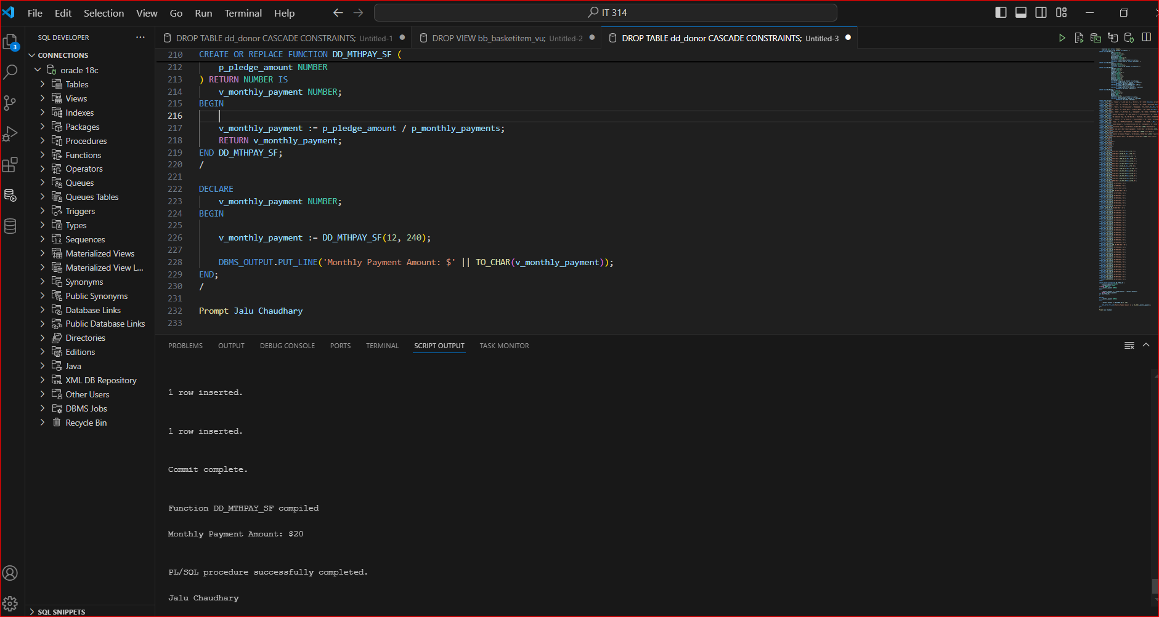

**Assignment 6-10: Calculating the Total Project Pledge Amount**

Create a function named DD_PROJTOT_SF that determines the total pledge amount for a project. Use the function in an SQL statement that lists all projects, displaying project ID, project name, and project pledge total amount. Format the pledge total to display zero if no pledges have been made so far, and have it show a dollar sign, comma, and two decimal places for dollar values.

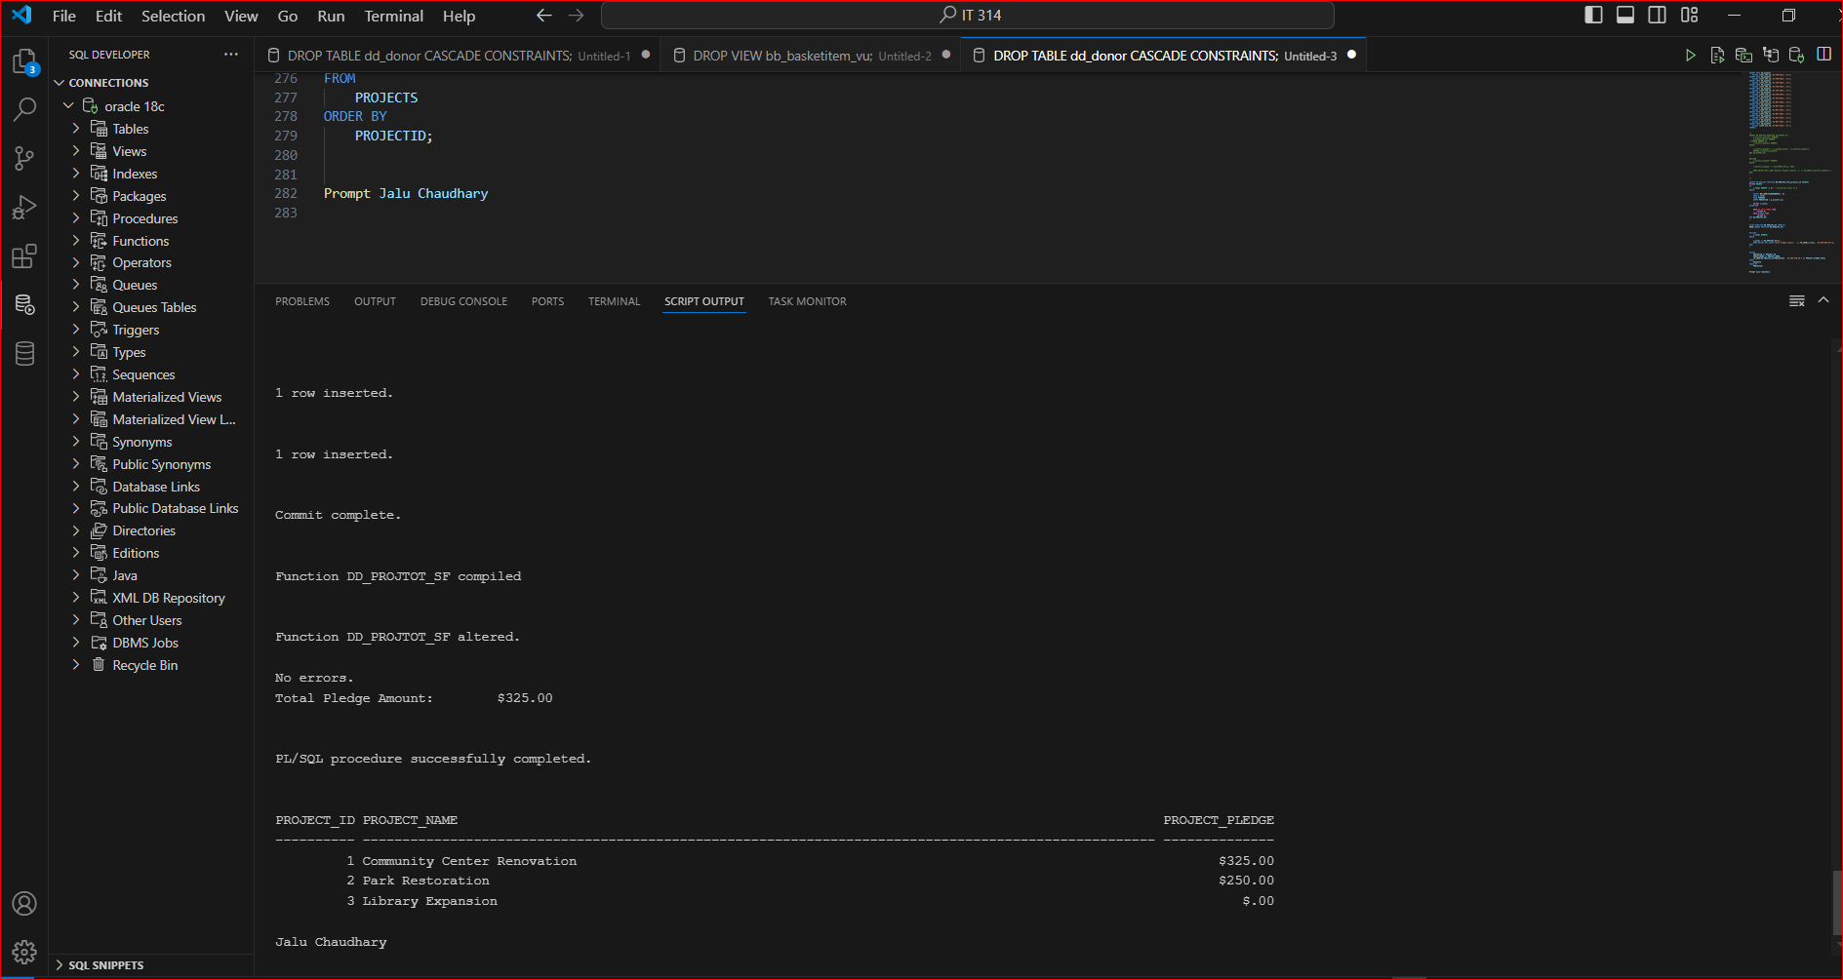

**Assignment 6-11: Identifying Pledge Status**

The DoGood Donor organization decided to reduce SQL join activity in its application by

eliminating the DD_STATUS table and replacing it with a function that returns a status description

based on the status ID value. Create this function and name it DD_PLSTAT_SF. Use the function

in an SQL statement that displays the pledge ID, pledge date, and pledge status for all pledges.

Also, use it in an SQL statement that displays the same values but for only a specified pledge.

